Yale UB’s

# Experian – UB’s

[https://claims.ecare.com](https://claims.ecare.com/)

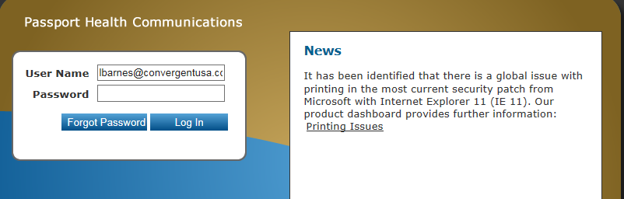

Enter user name and password then click log In

Type or paste the patient account number and click the search icon

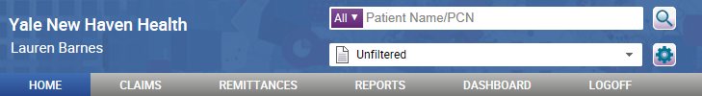

Your claim information will be displayed. Double click on desired patient and your UB will be shown.

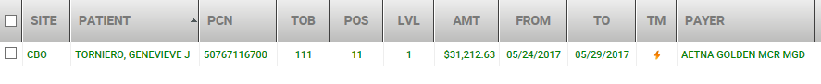

Right click on patient name Click on print then check the “Final” box. Then click Open.

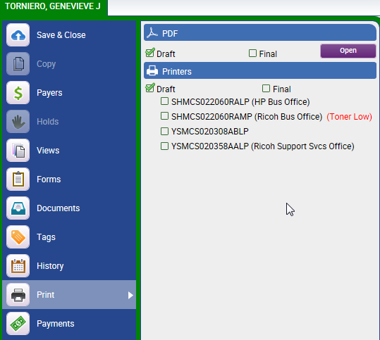

Click on Print Copy. Your UB will be displayed

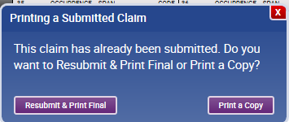



Select the print icon

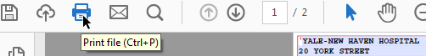

Scroll down to review the document. If there are several pages, you must choose the print current page

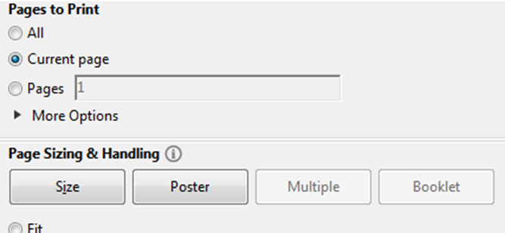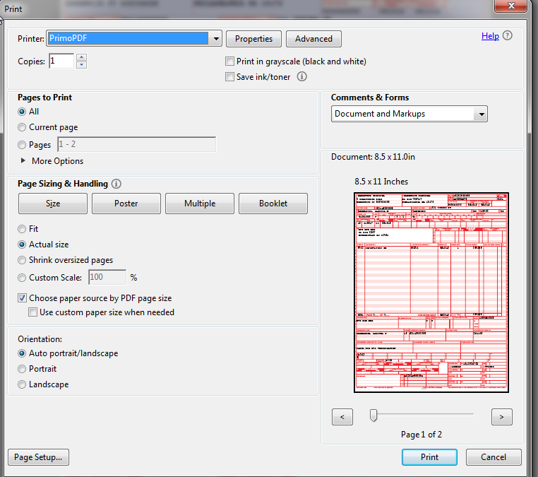

1. Select Ask when creating PDF at Save as Option, Do Nothing at Post Process option, and then select Create PDF.

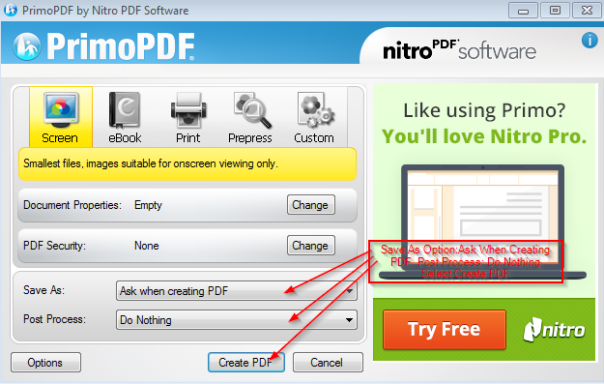

1. In the Save As Box go to Artiva (Y:), then select Artiva Images folder, then select HOSP folder, and Select UB04 folder

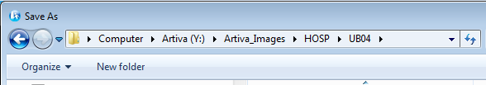

1. Select New Folder

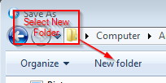

1. Label Folder with Column A - HCENID. Then double click on folder to open folder.

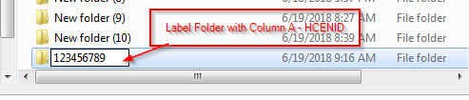

1. Label File Name with HCENID, Doc Type “UB”, and Date Doc was Created. Then select Save to save document to be uploaded into Artiva.

